Evidence of my text

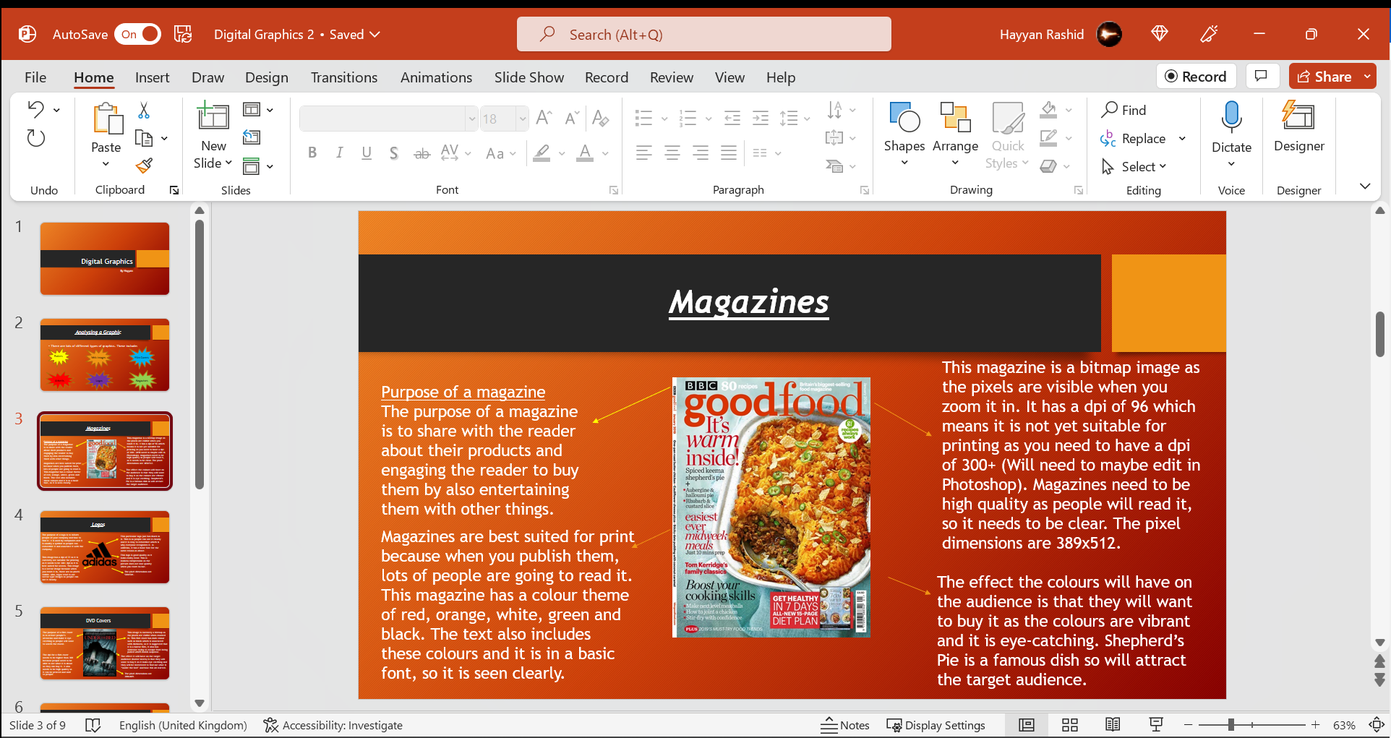

This screenshot shows the first slide which I am going to check for plagiarism.

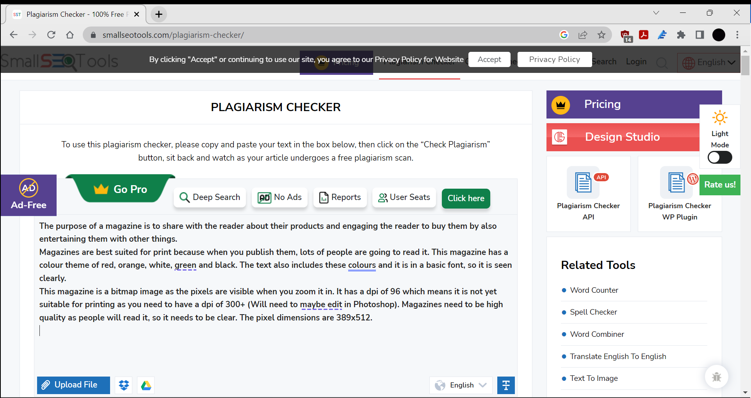

I entered the text into the box for checking.

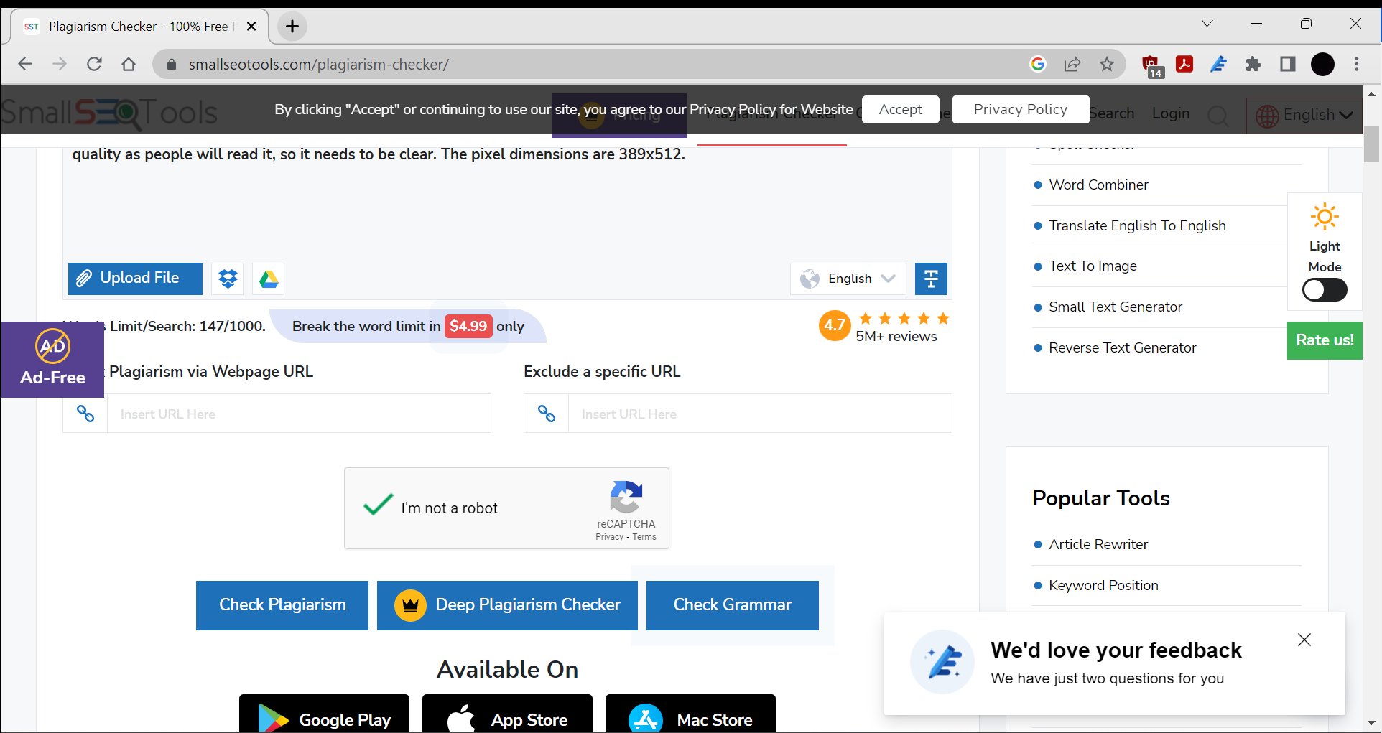

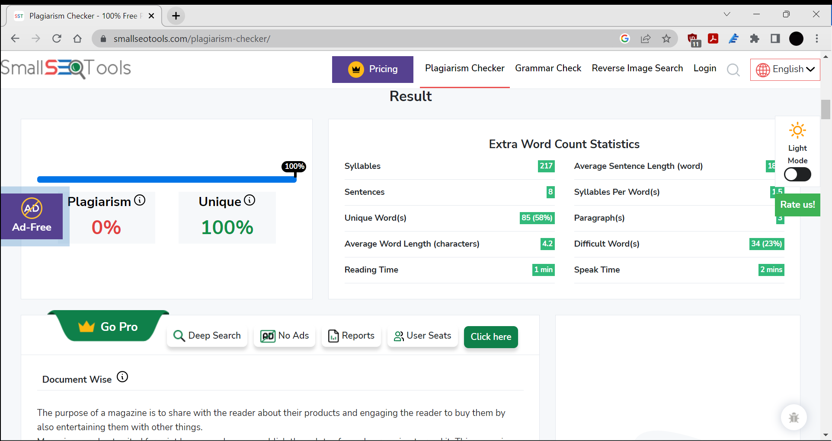

The results came back as 100% unique so I have not copied any text from the internet on this slide.

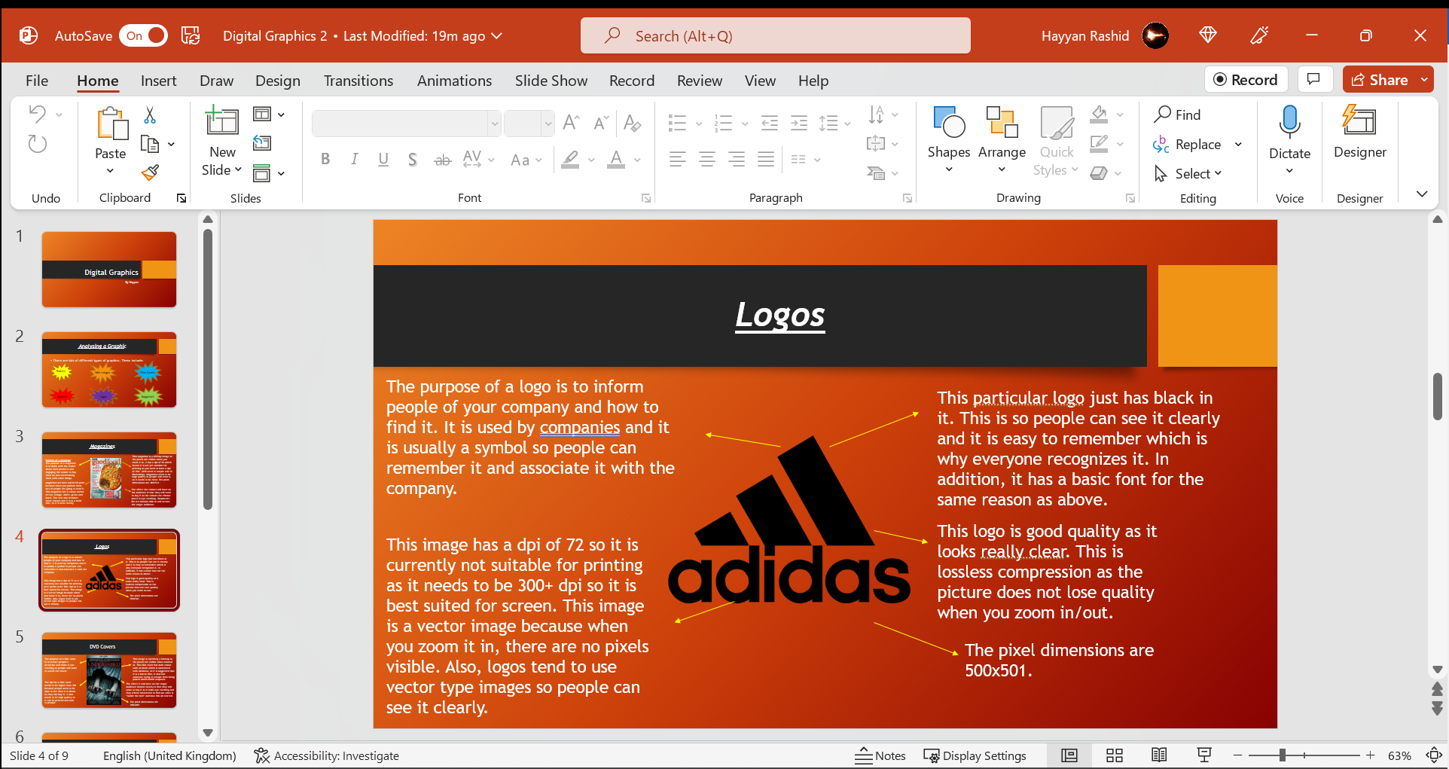

This screenshot shows my second slide which I am going to be checking for plagiarism.

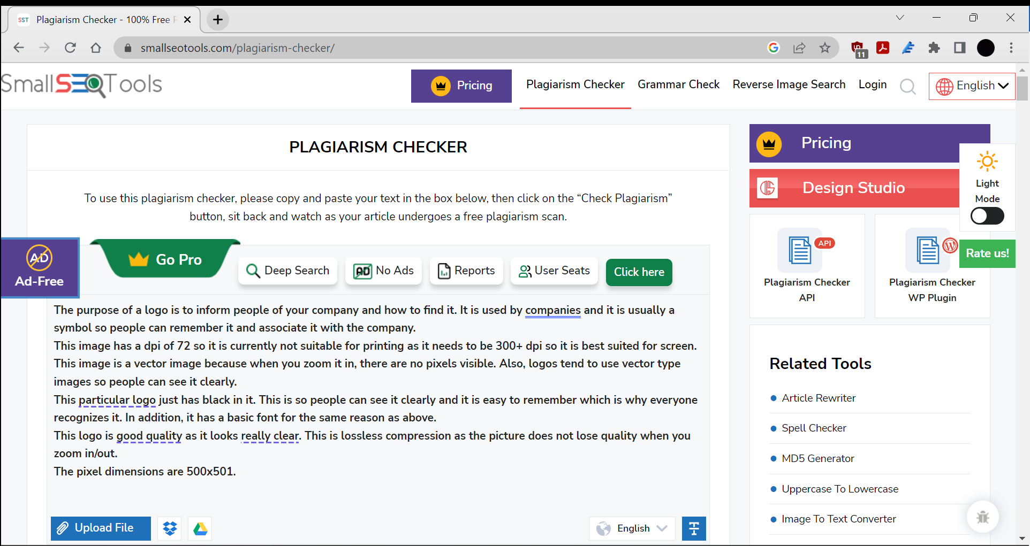

I placed the text into the box ready for checking.

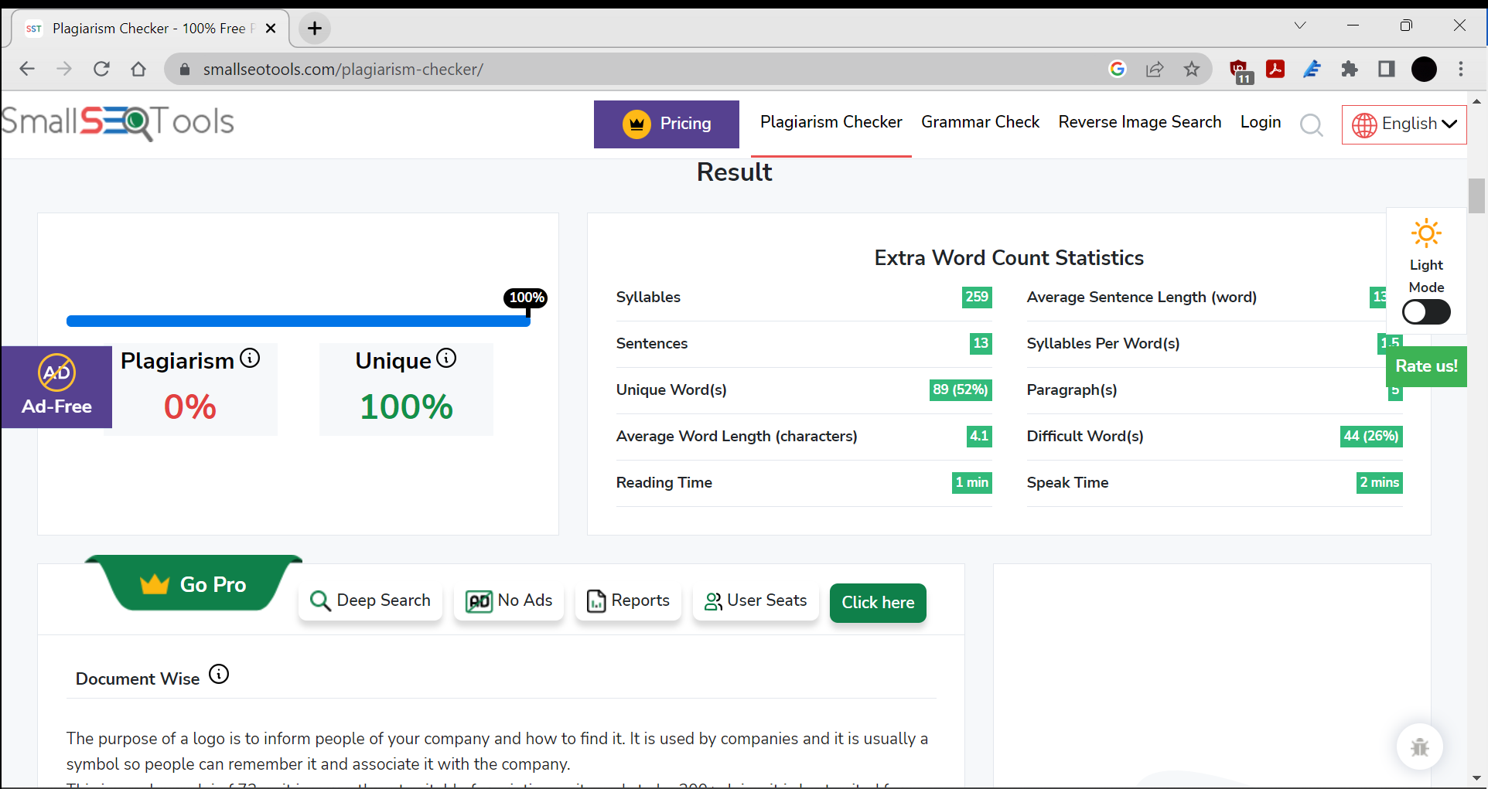

Result came back as 100% unique so it has not been copied.

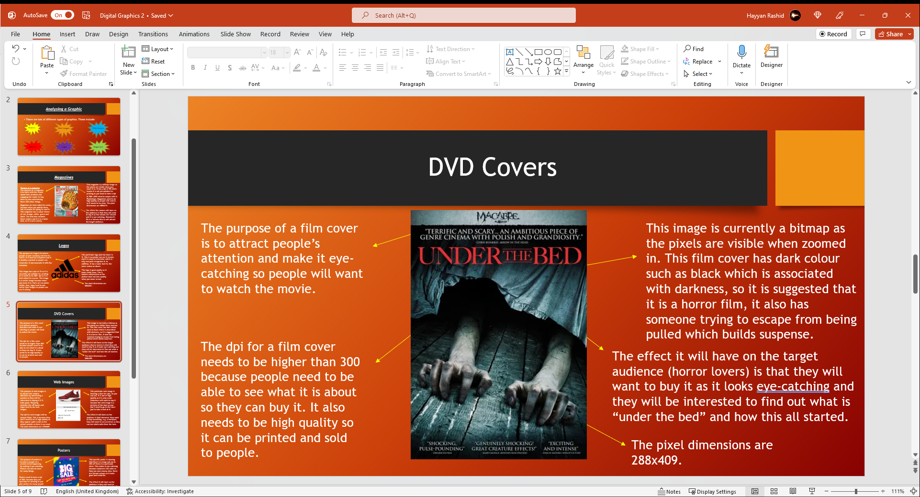

Checking 5th slide…

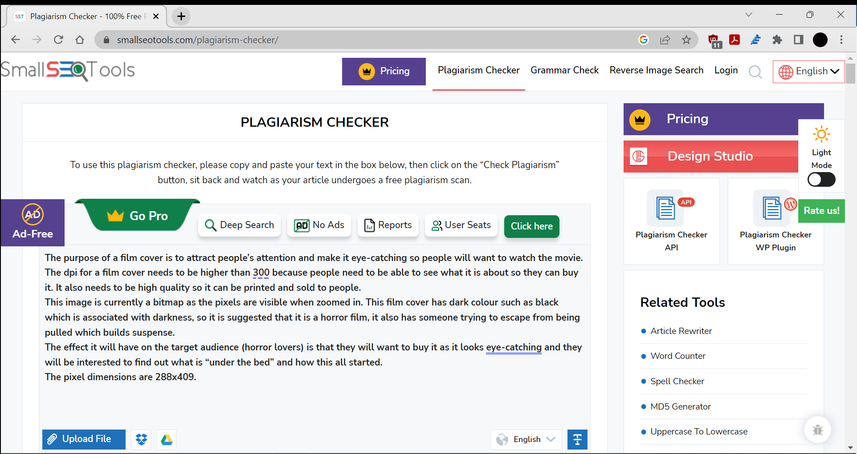

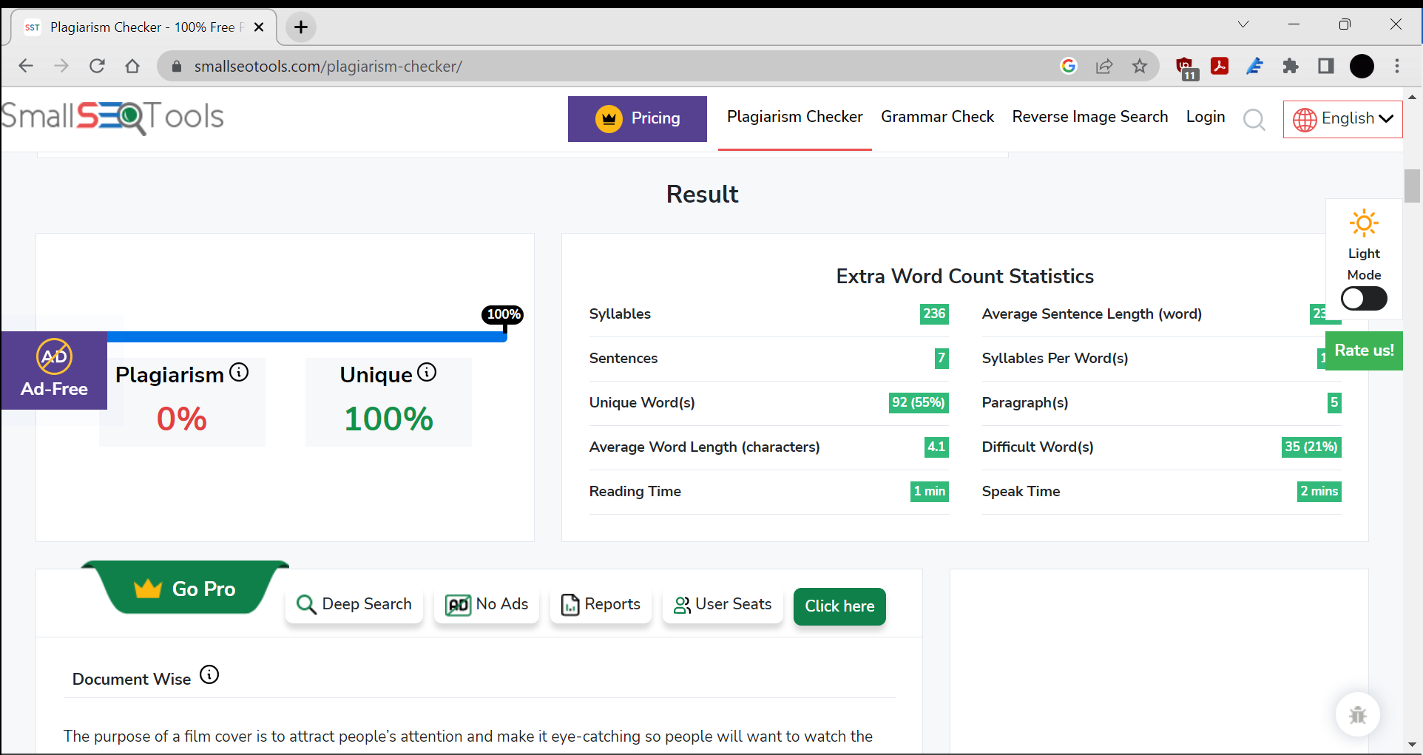

Result came back as 100% unique so it has not been copied from the internet.

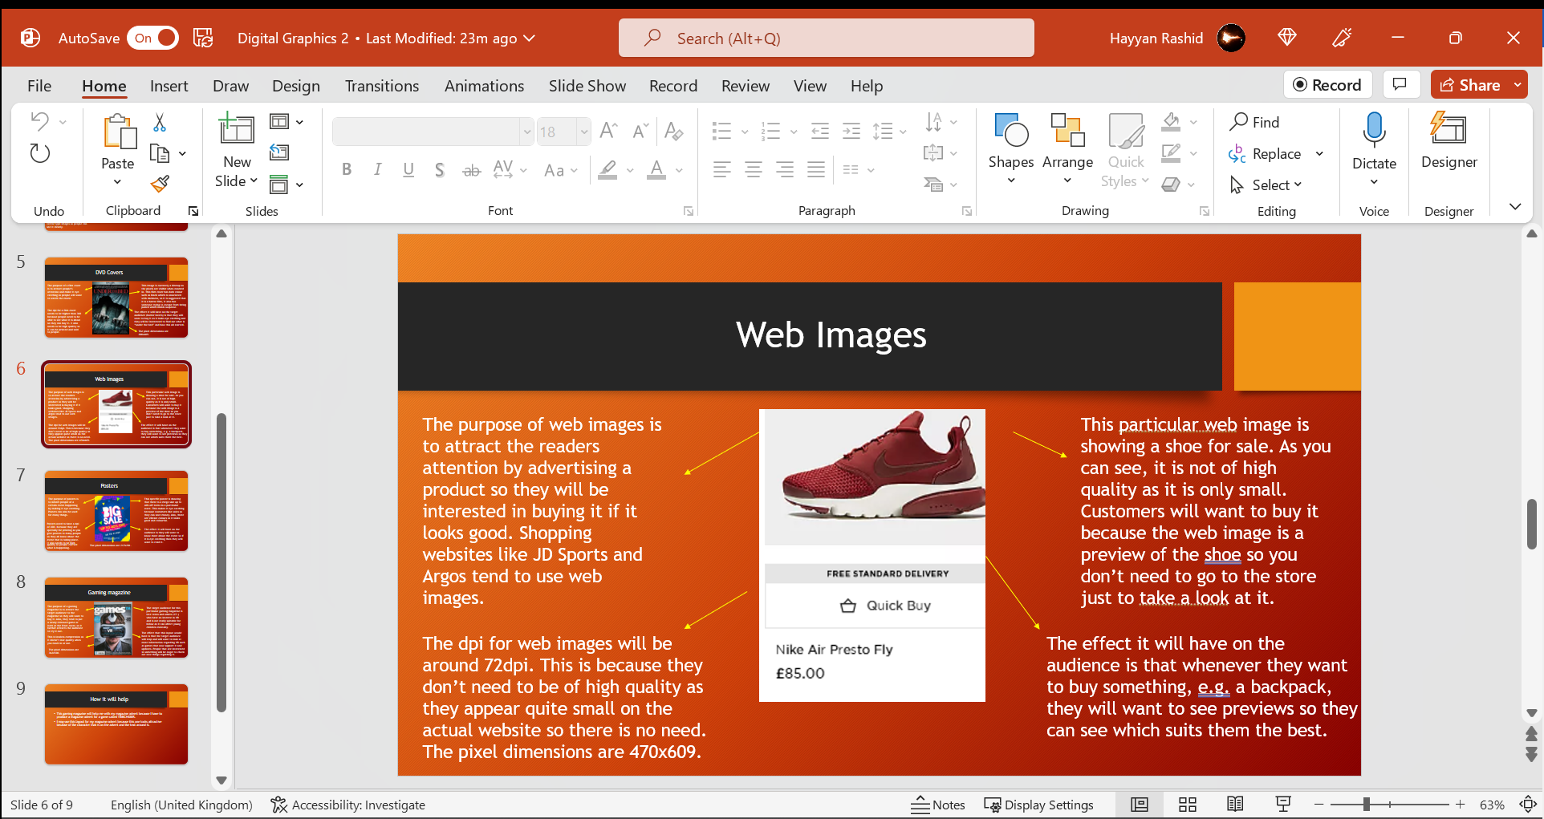

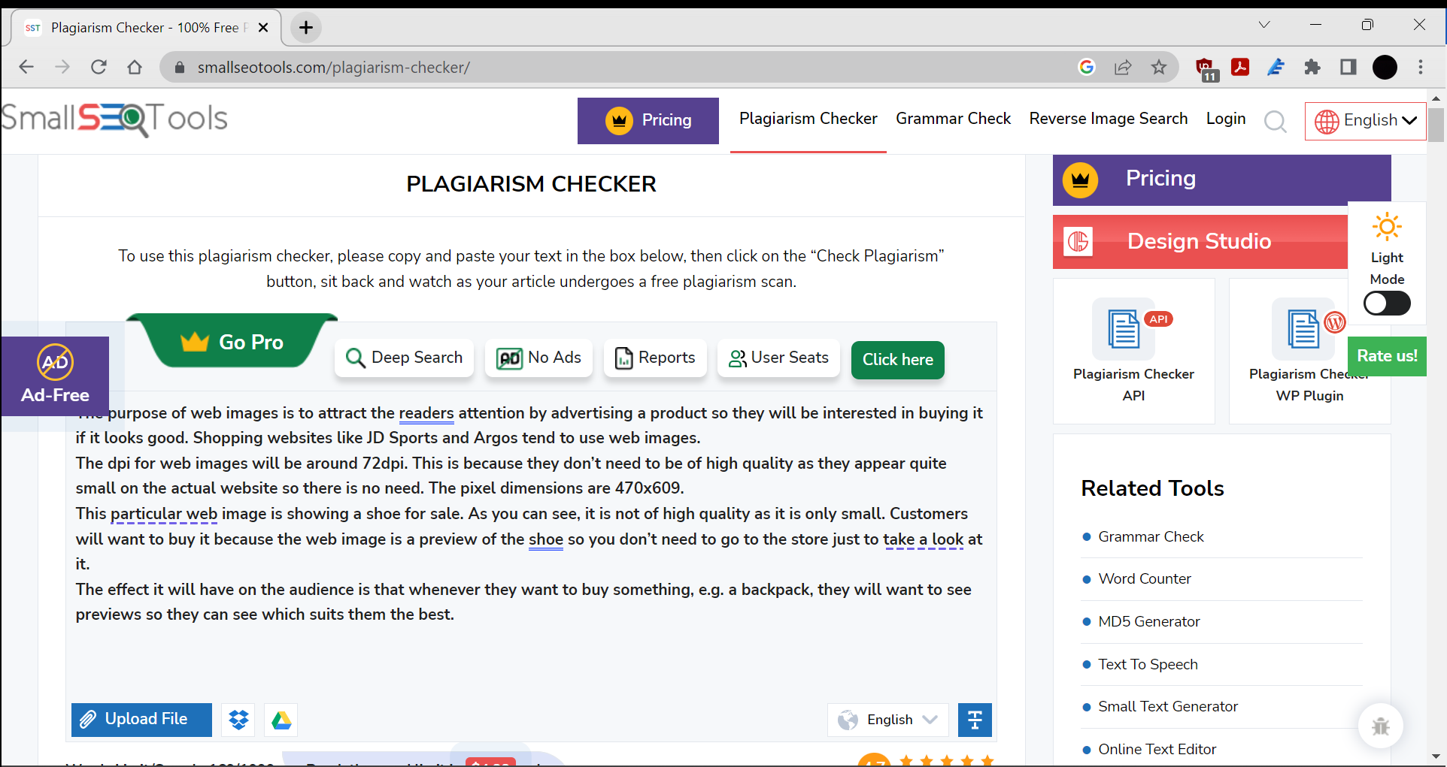

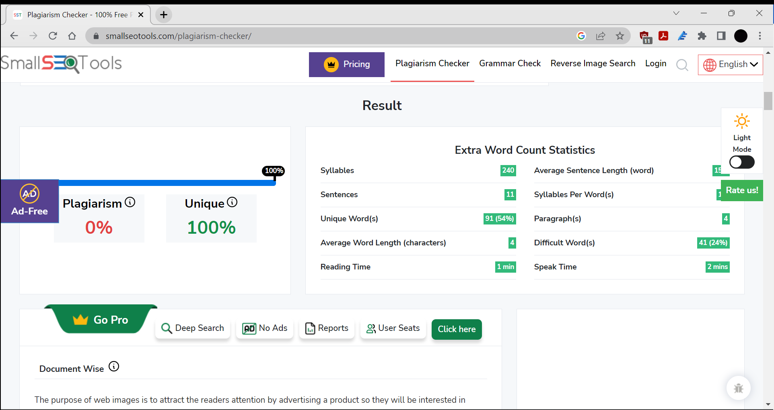

Result came back as 100% unique so it hasn’t been copied from the internet.

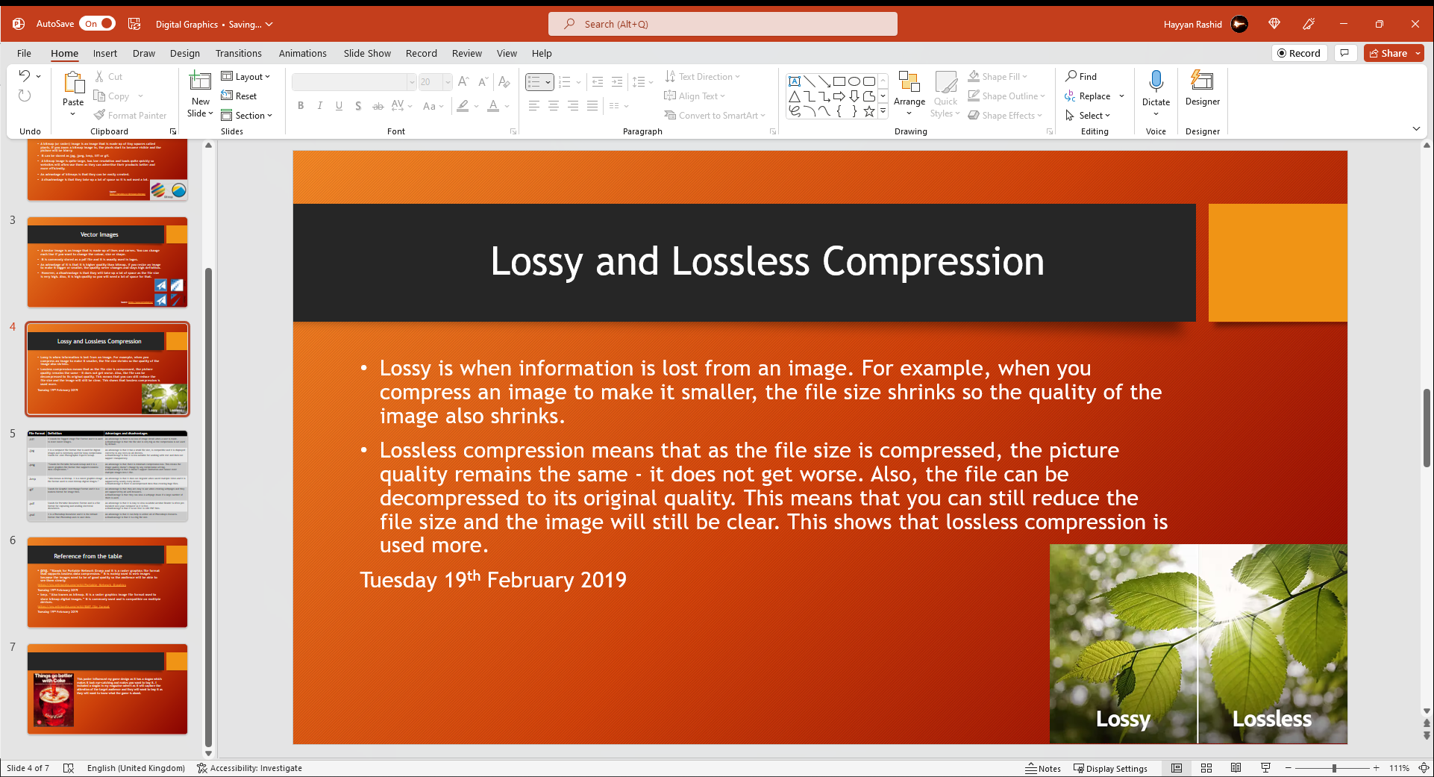

This is another slide that I am going to check for plagiarism.

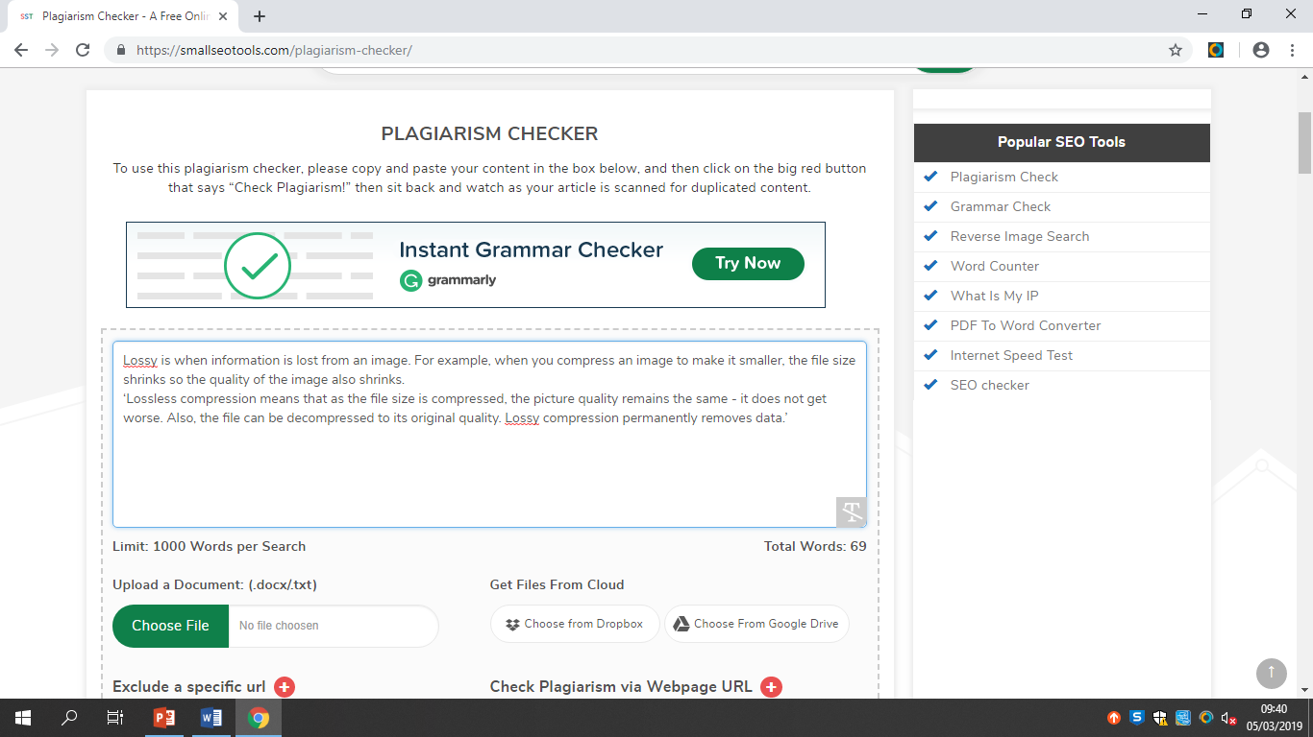

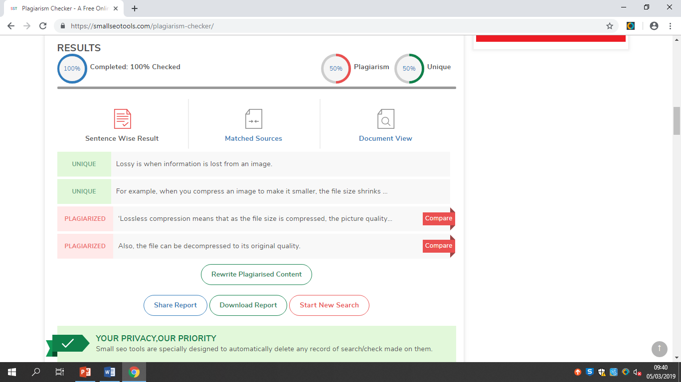

As you can see, the result came back as 50% unique which means I copied the second paragraph from the internet.

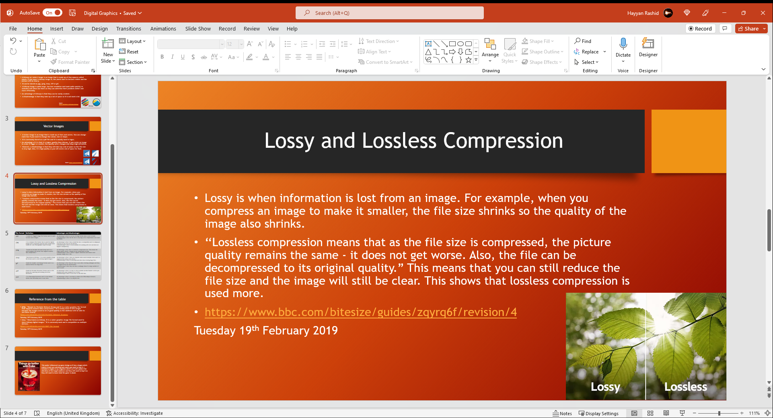

Because of this, I put quotation marks around the plagiarised text and put the reference of the text in a link.